**SOURCE CODE**

**Main method (Class: AccountRun)**

**package** object_oriented_programming;

**import** java.util.Scanner;

//Marasigan, Vem Aiensi

**public** **class** AccountRun

{

**static** Scanner *scan* = **new** Scanner(System.***in***);

**public** **static** **void** main(String[] args)

{

//Account 1

Account account1 = **new** Account();

account1.name = "Account 1";

account1.balance = 150;

account1.Show_Balance();

//Account 2

Account account2 = **new** Account();

account2.name = "Account 2";

account2.balance = 500.53;

account2.Show_Balance();

System.***out***.println();

System.***out***.print("Enter withdrawal for " +account1.name + ": ");

account1.withdrawal = *scan*.nextDouble();

System.***out***.println();

account1.debit();

account1.Show_Balance();

account2.Show_Balance();

System.***out***.println();

System.***out***.print("Enter withdrawal for " +account2.name + ": ");

account2.withdrawal = *scan*.nextDouble();

System.***out***.println();

account2.debit();

account1.Show_Balance();

account2.Show_Balance();

System.***out***.println();

}

}

**Class: Account & Method: debit**

**package** object_oriented_programming;

**import** java.text.DecimalFormat;

**public** **class** Account

{

DecimalFormat df = **new** DecimalFormat("$#,###.00");

String name = "";

**double** balance = 0;

**double** withdrawal = 0;

**void** debit()

{

System.***out***.print("Subtracting " + df.format(**this**.withdrawal)

+ " from " + **this**.name + "'s balance\n");

**if** (**this**.balance >= **this**.withdrawal)

{

**this**.balance -= **this**.withdrawal;

}

**else**

{

System.***out***.println("Debit amount exceeded account balance.");

}

}

**void** Show_Balance()

{

System.***out***.println(**this**.name + " balance: " + df.format(**this**.balance));

}

}

Sample Input/Output 1

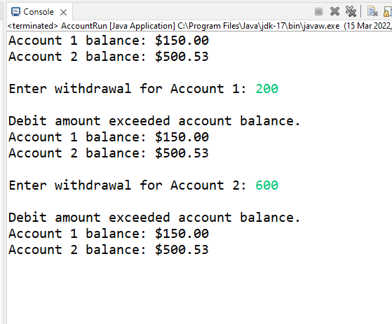

Sample Input/Output 2

